Free Swimming Lessons

Dear Parent/Guardian

Wrexham County Borough Council is providing free swimming lessons for children who haven’t reached the required swimming standard in their school lessons. These lessons will run during the school holidays and be taken by qualified swimming teachers, with the benefit of having smaller class sizes with others of similar ability.
The aim of the lessons is for children to become more confident in water but also where possible to reach the required National Curriculum standard. To enrol your child for these lessons please contact louise.brady@wrexham.gov.uk

Gwyn Evans Leisure and Activity Centre

4 day Course
Starting Tuesday 19th April - Friday 22nd April 2022
10.00am – 10.30am – Lesson 1
10.30am – 11.00am – Lesson 2

Yours Faithfully
Louise Brady
Sports Development Manager

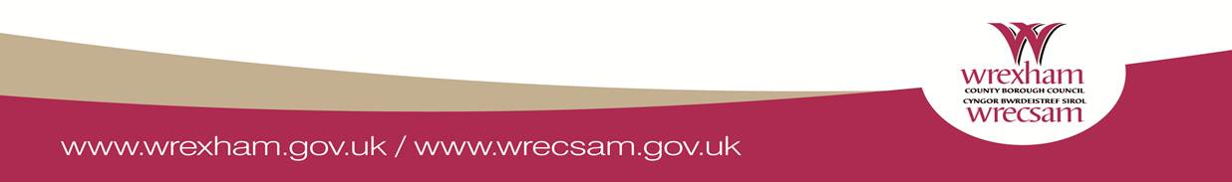

Gwersi Nofio am ddim

Annwyl Rhiant/Gwarchodwr

Mae Cyngor Bwrdeistref Sirol Wrecsam yn darparu gwersi ychwanegol yn rhad ac am ddim i blant nad ydynt wedi cyrraedd y safon nofio sy'n ofynnol yn eu gwersi nofio ysgol. Cynhelir y gwersi hyn yn ystod gwyliau'r ysgol gan athrawon nofio cymwysedig, gyda'r fantais o gael dosbarthiadau llai gydag eraill o allu tebyg. Nod y gwersi yw i blant ddod yn fwy hyderus yn y dŵr, ond hefyd lle bo modd, i gyrraedd safon y Cwricwlwm Cenedlaethol sy'n ofynnol. I gofrestru eich plentyn ar gyfer y gwersi hyn, cysylltwch louise.brady@wrexham.gov.uk

Canolfan Hamdden a Gweithgareddau Gwyn Evans
Cwrs 4 diwrnod
Yn cychwyn Dydd Mawrth 19eg Ebrill – Dydd Gwener 22ain Ebrill 2022
10.00am – 10.30am – Gwers 1
10.30am -11.00am - Gwers 2

Yn Gywir
Louise Brady
Rheolwr Datblygu Chwaraeon

